NOTIFICATION OF WORKS

The Shire of Capel wishes to advise residents and the wider community that bridge upgrade works will be commencing for the following;

Scope of WORKS | Carry out required bridge upgrade works following safety inspection. Detours in place - 3-4 km detour route.
Works LOCATION | Bridge 408 Clapp Road Capel
Nearest INTERSECTION | Mathews Road Capel and Vickery Road Elgin
Planned START DATE | CLOSED 31/11/23
Planned FINISH DATE | TBC
Traffic Management | - Water filled barriers  - Detour signage
Contractor | TBC
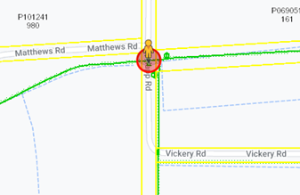

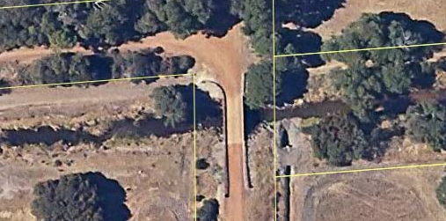

The Shire of Capel thanks you for your patience whilst bridge upgrade works are carried out. Should you have any enquiries or concerns regarding the works, please do not hesitate to contact Water Corporation 13 13 75 (24-hour fault line).

