NOTIFICATION OF WORKS

The Shire of Capel wishes to advise residents and the wider community that a portion of footpath parallel to South Western Highway Boyanup will commence construction.

Scope of WORKS | Construct new footpath parallel to South Western Highway
Works LOCATION | South Western Highway Boyanup railway crossing
Nearest INTERSECTION | Turner Street and Bridge Street
Planned START DATE | Monday 11th December 2023
Planned FINISH DATE | Saturday 23rd December 2023
Traffic Management | - Water filled barriers  - Safety signage  - Traffic cones  - Pedestrian diversion signage
Contractor | Jetline Kerbing Contractors / Forge Civil
GUIDE ONLY: Footpath construction (blue line)
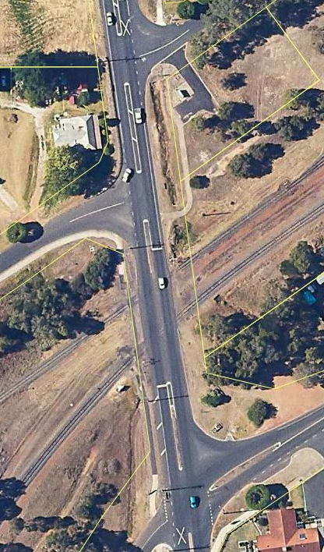

The Shire of Capel thanks you for your patience whilst footpath construction works are carried out. Should you have any enquiries or concerns regarding the works, please do not hesitate to contact Shire of Capel on 9727 0222.

