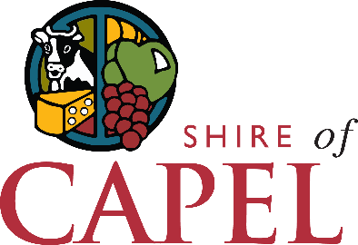
Club Development – Strategic Planning

Expression of Interest
EOI Closes on the 12th of February 2024
The Shire of Capel is seeking expressions of interest from local sporting clubs to undertake a series of workshops to develop their club’s strategic plan.
These workshops have been made possible with grant funding received from the Department of Local Government, Sport, and Cultural Industries. The funding allows for two clubs per year to have a consultant work with your club to develop a 3–5-year strategic plan. Sporting clubs are invited to submit the following expression of interest form to assist the Shire of Capel’s Community Development team to prioritise the facilitation of the strategic planning workshops.

How to submit
Fax this form to the Community Development Team on 9727 0223
Email it to info@capel.wa.gov.au
Hand deliver it to the Community Development Team at the Shire Administration building, Forrest Road, Capel

Section 1 – Club Details

Club Name
Title |  | Given name(s) |  | Surname |  |  |  | Position Held at Club
Phone number |  |  |  |  | Email

Club Address
Signature |  |  |  |  |  | Date

Section 2 – Club Application

Has your Club ever developed a Strategic Plan? If yes, please provide a copy with this form.

 | YES (attach a copy of the plan) |  |  | NO

How will creating a Strategic Plan, or updating your existing plan, benefit your Club?

Does your Club currently have a full committee?

 | YES |  |  | NO

Who is your committee made up of (committee positions)? Please advise vacant positions.

How many social and player members does your club have?

Provide a brief overview of your Club’s goals for the next 2-5 years.

